HIGH COURT OF PUNJAB & HARYANA CHANDIGARH

E-Filing Portal User Manual

Done By : PRIYAL SHRIVASTAVA

Table of Contents

Section No | Module / Page Name | Page No.
1 | Introduction | 3 - 4
2 | Login Page | 5 - 8
3 | Home Page Dashboard | 9 - 16
4 | Start e-Filing | 17
5 | Start New e-Filing | 17 - 20
6 | Application e-Filing | 21 - 23
7 | Caveat e-Filing | 24 - 27
8 | Resume e-Filing | 27 - 29
9 | Reports of Submitted e-Filing | 30 - 33
10 | Objection Cases | 33 - 35
11 | Mentioning Status | 35 - 37
12 | Additional Court Fee | 37 - 39
13 | Logout | 40

Introduction

Overview
The E-Filing Portal is a secure web-based platform developed to facilitate the electronic filing and management of cases, applications, and related legal documents before the Hon'ble Punjab and Haryana High Court. The portal enables users to submit filings online, track their progress, respond to objections, pay additional court fees, and monitor case registration status without the need for physical submission of documents.
The system is designed to streamline the filing process, improve transparency, reduce paperwork, and provide users with real-time access to the status of their filings.

Purpose of the Portal
The primary objectives of the E-Filing Portal are:

    - To provide a convenient and secure platform for electronic filing.
    - To reduce manual paperwork and physical visits to the court.
    - To enable users to track the status of their filings online.
    - To facilitate faster scrutiny and processing of filed cases.
    - To provide online payment facilities for additional court fees.
    - To improve communication between users and the court registry.

Intended Users
The E-Filing Portal is accessible to the following categories of users:

Advocates
Registered advocates can use the portal to file new cases, applications, caveats, and manage their filing activities electronically.

Party-in-Person / Litigants
Individuals representing themselves before the Court can use the portal to submit and manage their filings without engaging an advocate.

Key Features
The portal offers the following major functionalities:

    - Secure user authentication and login.
    - New case e-Filing.
    - Application e-Filing.
    - Caveat e-Filing.
    - Draft saving and resuming of incomplete filings.
    - Tracking of filing status and scrutiny progress.
    - Objection management and compliance submission.
    - Online payment of additional court fees.
    - Mentioning status updates.
    - Filing reports and submission history.
    - Notifications, guidelines, and user assistance resources.
    - Dashboard-based monitoring of all filing activities.

System Workflow
The typical workflow within the E-Filing Portal is as follows:

- User logs into the portal.
- User initiates a new filing, application filing, or caveat filing.
- Required case details and documents are submitted.
- The filing is scrutinized by the Registry.
- Objections, if any, are communicated through the portal.
- The user rectifies and resubmits the filing where required.
- Upon successful scrutiny, the filing is approved and registered.
- Users can track the status of their filings throughout the process.

User Manual Structure
This user manual provides detailed guidance for each module of the E-Filing Portal, including:

    - Login Page
    - Home Page Dashboard
    - Start New e-Filing
    - Application e-Filing
    - Caveat e-Filing
    - Resume e-Filing
    - Reports of Submitted e-Filing
    - Objection Cases
    - Additional Court Fee
    - Mentioning Status
    - Notifications & Guidelines
    - User Manual & Help Videos
    - Logout

Login Page

Overview
The Login Page serves as the entry point to the E-Filing Portal. Users must authenticate themselves before accessing the portal's services and filing modules.
The portal supports two categories of users:

- Advocate
- Party-in-Person / Litigant

Each user category is provided with appropriate authentication methods to ensure secure access to the system.

User Type Selection
Upon opening the E-Filing Portal, users are required to select their user category from the available options:

Advocate
Registered advocates can access the portal using either:

    - Enrollment Number and Password
    - Mobile OTP

Party-in-Person / Litigant
Party-in-Person users and Litigants can access the portal using:

    - Mobile OTP

Advocate Login

Option 1: Login using Enrollment Number and Password
This login method is available for registered advocates.

Steps:

- Select Advocate as the user type.

Choose Enrollment Number & Password Login.
- Enter the registered Enrollment Number.
- Enter the corresponding Password.
- Click the Login button.
- Upon successful authentication, the system redirects the user to the Home Page Dashboard.
- 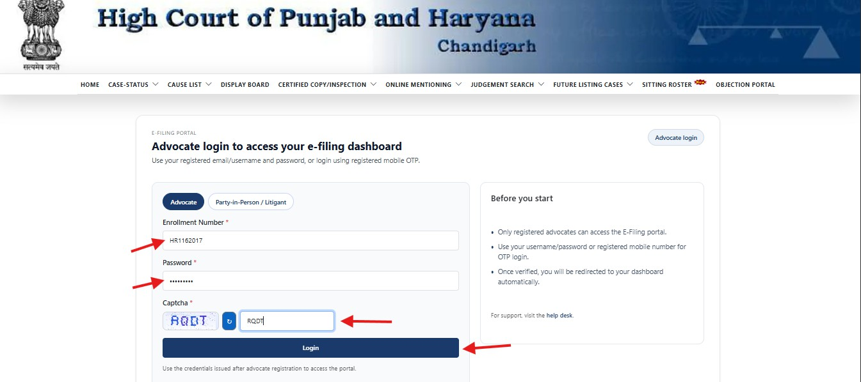

Option 2: Login using Mobile OTP
This login method allows advocates to access the portal using their registered mobile number.

Steps:

- Select Advocate as the user type.
- Choose Login via Mobile OTP.
- Enter the registered mobile number.
- Click Send OTP.
- Enter the OTP received on the registered mobile number.
- Click Verify & Login.
- Upon successful verification, the system redirects the user to the Home Page Dashboard.

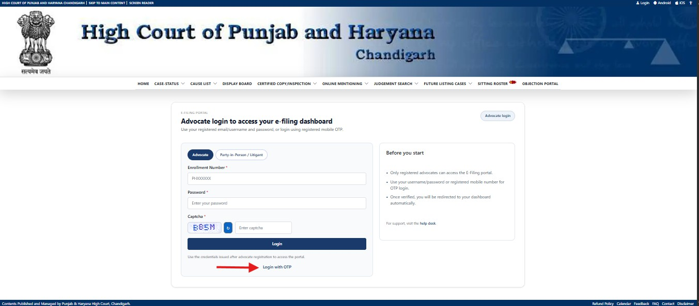
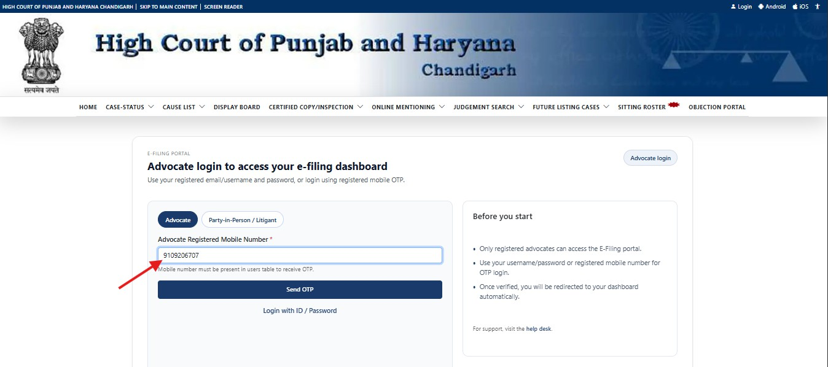

Party-in-Person / Litigant Login
Party-in-Person users and Litigants can log in through OTP-based authentication.

Steps:

- Select Party-in-Person / Litigant as the user type.
- Enter the registered mobile number.

- Click Send OTP.
- Enter the OTP received on the registered mobile number.
- Click Verify & Login.
- Upon successful verification, the system redirects the user to the Home Page Dashboard.
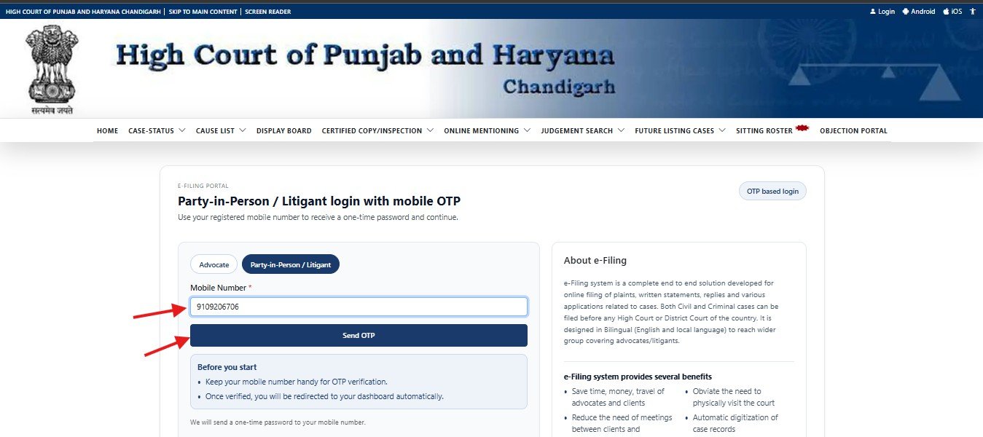

Successful Login
After successful authentication, the user is redirected to the Home Page Dashboard, where all e-Filing services and filing status information are available.
The Home Page Dashboard is explained in the next chapter.

Home Page Dashboard

Overview
After successful login, the user is redirected to the Home Page Dashboard. The dashboard serves as the central workspace of the E-Filing Portal, providing quick access to filing services, status tracking, reports, notifications, and support resources.
The dashboard is designed to help users efficiently manage their e-Filing activities from a single screen.

Dashboard Components
The Home Page Dashboard consists of the following sections:

- Header Section
- Quick Action Cards
- Start e-Filing Section
- Resume & Reports Section
- Help & Support Section
- E-Filing Summary Dashboard

Header Section
The Header Section is displayed at the top of the dashboard and contains user and session-related information.

User Information
This section displays:

    - Name of the logged-in user
    - User category (Advocate / Party-in-Person)
    - Registration details associated with the account

Session Timer

The session timer displays the remaining active session duration. Users are advised to save their work periodically to avoid loss of data due to session expiry.

Current Date and Time
The current system date and time are displayed for reference.

Logout
The Logout button allows users to securely sign out of the portal after completing their activities.
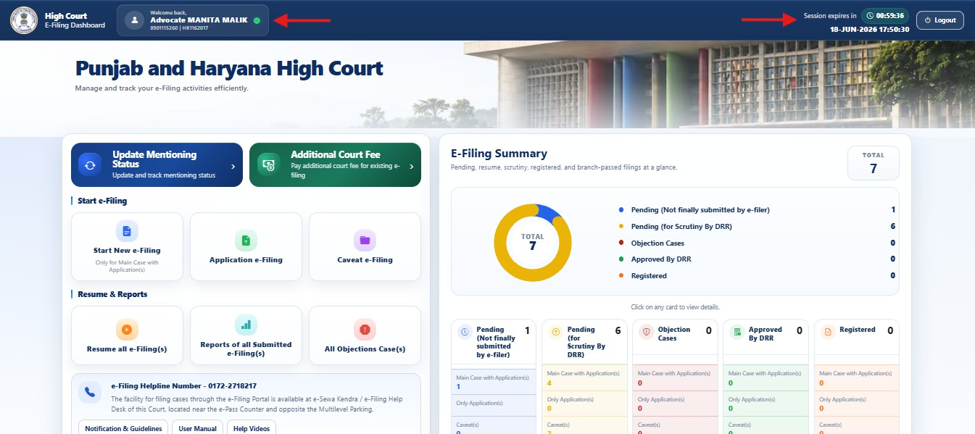

Quick Action Cards
Quick Action Cards provide direct access to frequently used functions.

Update Mentioning Status
This option enables users to:

    - View mentioning requests
    - Check mentioning status
    - Access mentioning-related information and updates

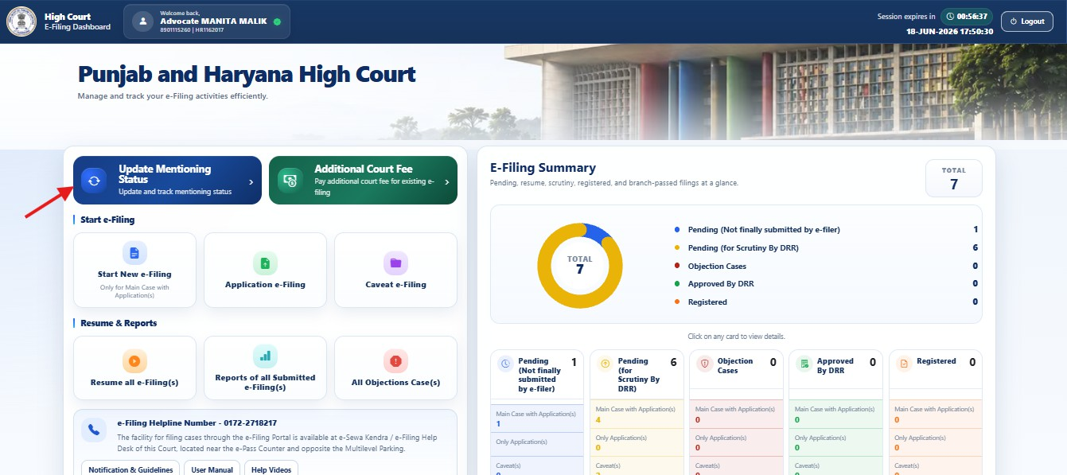

Additional Court Fee
This option enables users to:

    - Pay additional court fees for existing filings
    - View pending fee requirements
    - Complete fee payment processes online
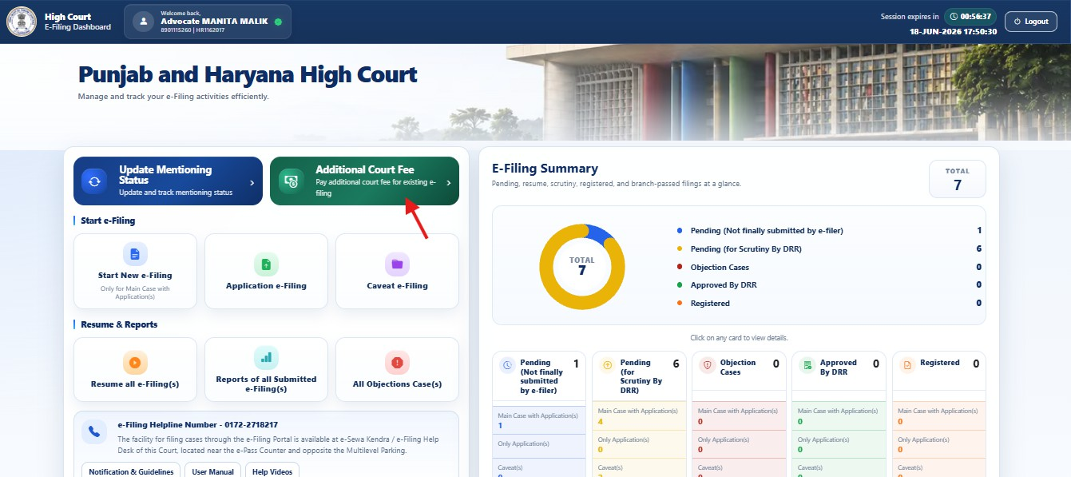

Start e-Filing Section
The Start e-Filing section allows users to initiate new filing activities.

Start New e-Filing
This option is used to:

    - File a new main case
    - Initiate a fresh e-Filing process
    - Submit case-related documents electronically

Application e-Filing
This option is used to:

    - File applications related to existing matters
    - Submit miscellaneous applications
    - Upload supporting documents for applications

Caveat e-Filing
This option is used to:

    - File caveat petitions electronically
    - Manage caveat-related submissions through the portal
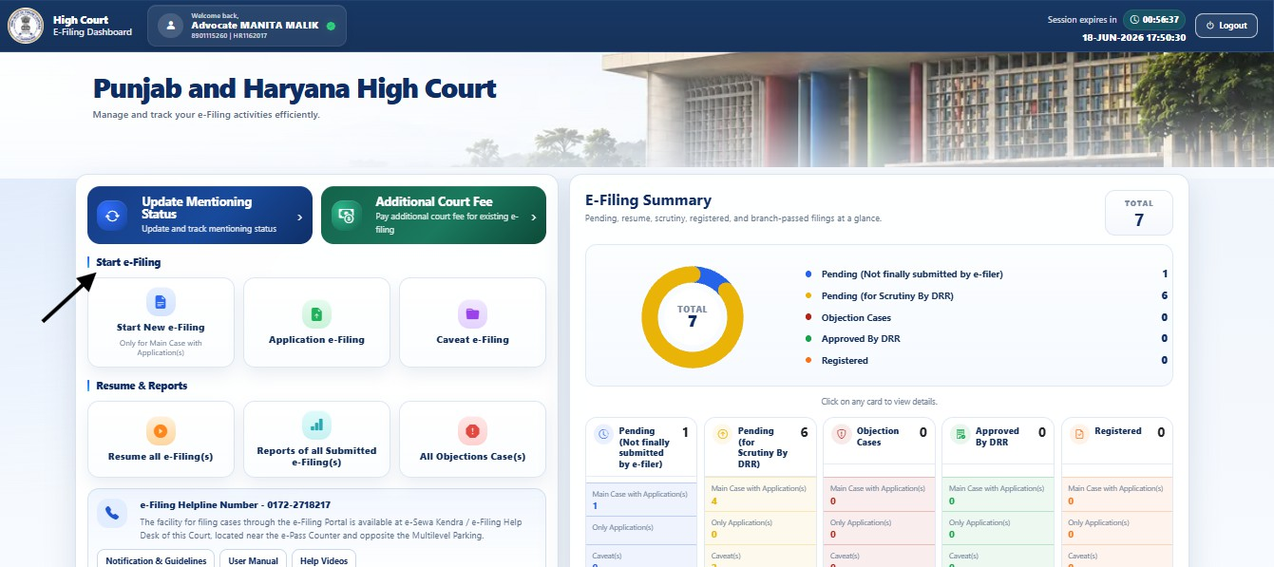

Resume & Reports Section
This section allows users to access previously saved filings and filing reports.

Resume All e-Filing(s)
This feature allows users to:

    - Continue incomplete filings
    - Edit saved drafts
    - Complete pending filing processes

Reports of All Submitted e-Filing(s)
This feature allows users to:

    - View previously submitted filings
    - Track filing history
    - Review filing details and current status

All Objection Cases
This feature allows users to:

    - View cases where objections have been raised
    - Check objection details
    - Monitor compliance and rectification status
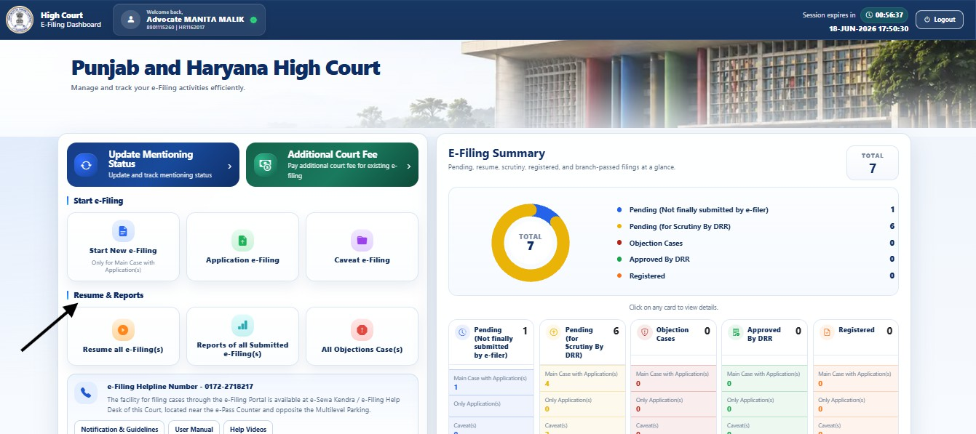

Help & Support Section
The Help & Support section provides assistance and important resources to users.

Filing Helpline
Displays the official helpline number for obtaining assistance regarding portal-related issues.

Notification & Guidelines
Provides access to:

  - Official notifications
  - Court guidelines
  - Filing instructions and updates

User Manual
Provides access to the complete user documentation for the E-Filing Portal.

Help Videos
Provides instructional videos explaining various portal functionalities and filing procedures.
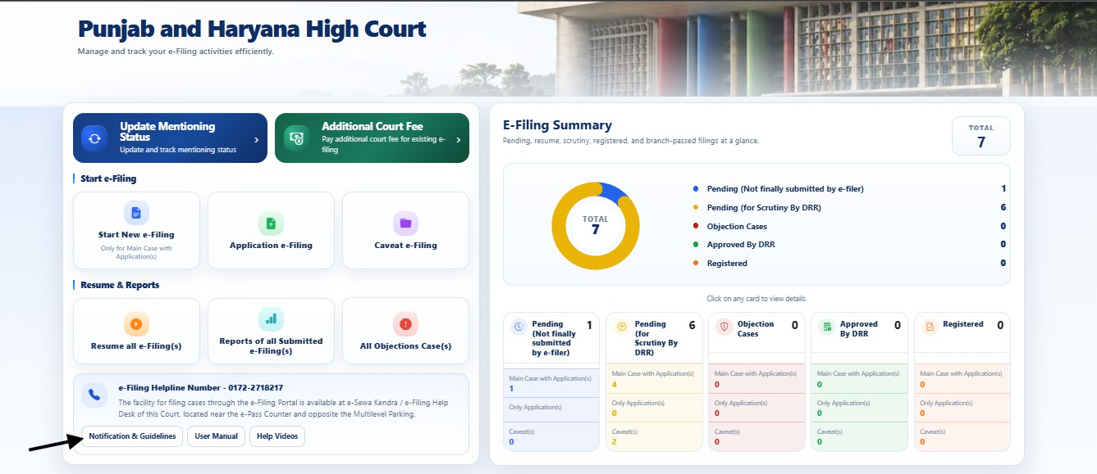

E-Filing Summary Dashboard

The E-Filing Summary Dashboard provides a consolidated view of all filing activities associated with the user's account.
A graphical summary and statistical information are displayed to help users quickly understand the status of their filings.

Total Filings
Displays the total number of filings currently associated with the user account.

Filing Status Categories
The dashboard categorizes filings into the following statuses:

Pending (Not Finally Submitted by e-Filer)

Displays filings that have been saved but have not yet been finally submitted.

Pending (for Scrutiny by DRR)

Displays filings that have been submitted and are awaiting scrutiny by the Registry.

Objection Cases

Displays filings in which objections have been raised and corrective action is required.

Approved by DRR

Displays filings that have successfully completed scrutiny and have been approved.

Registered

Displays filings that have been formally registered by the Court.

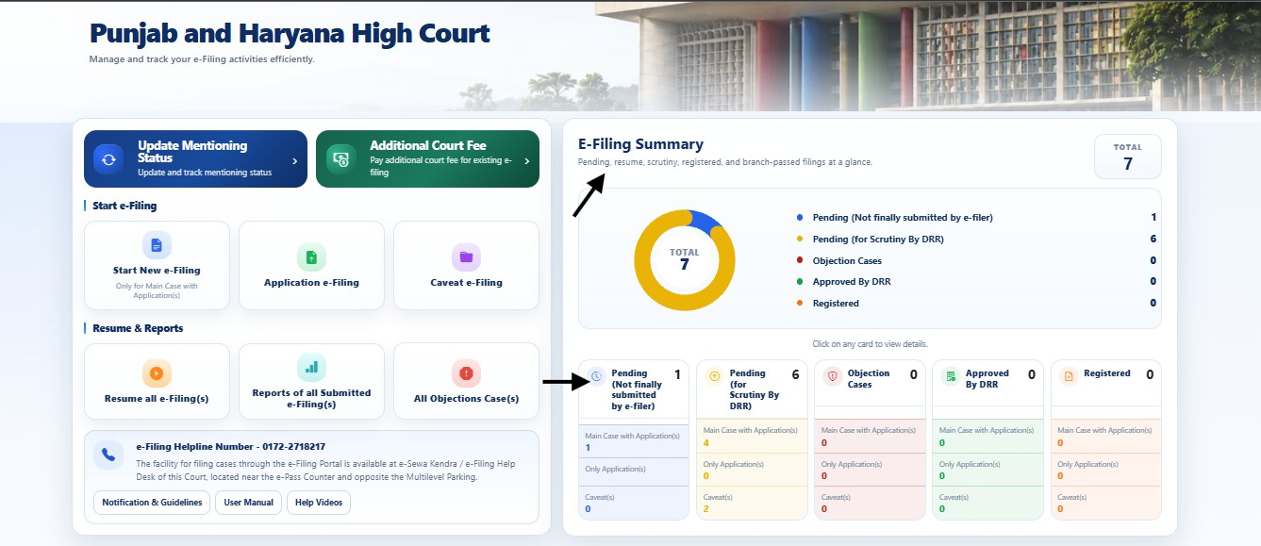

Dashboard Benefits
The Home Page Dashboard enables users to:

    - Initiate new filings
    - Resume incomplete filings
    - Monitor filing progress
    - View objections and compliance requirements
    - Track scrutiny and registration status
    - Pay additional court fees
    - Access notifications and guidelines
    - Obtain support through help resources
    - Manage all e-Filing activities from a centralized interface

The Home Page Dashboard serves as the primary navigation and monitoring screen of the E-Filing Portal.

Start e-Filing

Overview
The Start e-Filing module enables users to initiate and submit new filings through the E-Filing Portal. This module provides options for filing a new case, submitting applications, and filing caveat petitions electronically.
Users can access the Start e-Filing section directly from the Home Page Dashboard.

The module is designed to simplify the filing process by allowing users to enter case details, upload required documents, and submit filings online.

Accessing Start e-Filing
To access the Start e-Filing module:

- Log in to the E-Filing Portal.
- Navigate to the Home Page Dashboard.
- Locate the Start e-Filing section.
- Select the required filing option.

The following filing options are available:

  - Start New e-Filing
  - Application e-Filing
  - Caveat e-Filing

Start New e-Filing

Overview
The Start New e-Filing module enables users to initiate a fresh case filing through the E-Filing Portal. This module captures the case details, petitioner information, respondent information, advocate details, supporting documents, payment details, and generates the E-Filing Number upon successful submission.
The filing process is divided into multiple stages to ensure that all required information is collected systematically.

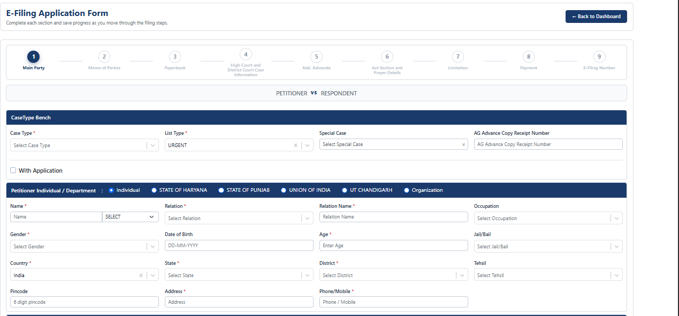

Start New e-Filing Workflow
The fresh case submission process is completed through the following nine sequential stages:

Main Party → Memo of Parties → Paperbook → High Court and District Court Case Information
→ Add. Advocate → Act-Section and Prayer Details → Limitation → Payment → E-Filing Number

Users can navigate through these stages sequentially by completing and saving the required information at each step.

Main Party Setup
In this foundational step, users are required to configure the core administrative criteria for the new case.

CaseType Bench Configurations
The following case operational details must be selected:
    - Case Type * → Select the applicable classification from the dropdown list (e.g., CWP, CRM-M, CRA, etc.).
    - List Type * → Pick the default urgency designation (e.g., URGENT).
    - Special Case → If the litigation qualifies for a priority category (such as Senior Citizen, Women, Juvenile), specify it here.
    - AG Advance Copy Receipt Number → Input the verified receipt number confirming that an advance copy has been served to the Advocate General's office.
    - With Application Checkbox → Tick this option if you are filing interlocutory or miscellaneous applications concurrently with the main petition.

Party Type Selection
Users must select the appropriate legal entity category for the primary petitioner: Individual → State of Haryana → State of Punjab → Union of India → UT Chandigarh → Organization

Petitioner Details
The Petitioner section captures vital demographics and contact data of the filing party. Depending upon the selected party type, users are required to provide:

Name *
    - Relation * (e.g., S/o, D/o, W/o)
    - Relation Name *
    - Occupation
    - Gender *
    - Date of Birth
    - Age *
    - Jail/Bail Status (Applicable under criminal jurisdictions)
    - Country * (Pre-selected to India)
    - State *
    - District *
    - Tehsil
    - Pincode (6 digits)

Address *
    - Phone/Mobile *
⚠ Note
All mandatory fields marked with an asterisk (*) must be completed before the system validates progress to the next step.

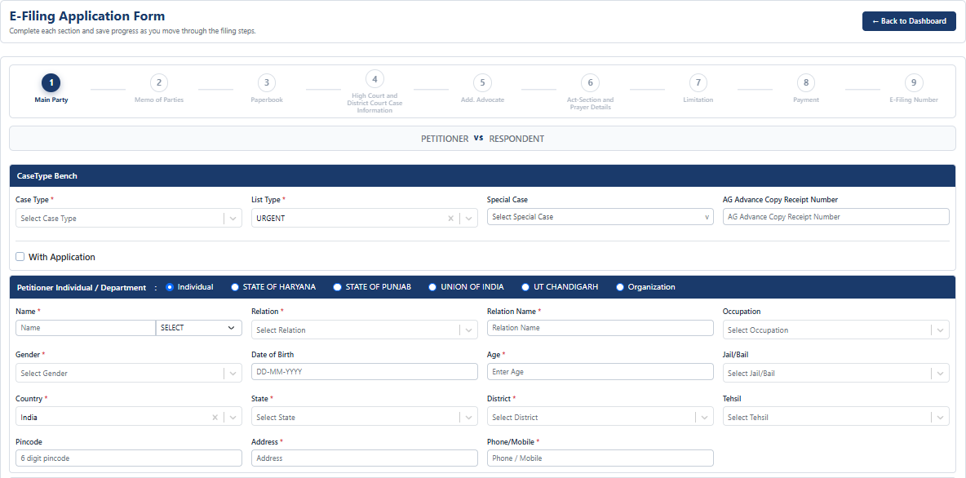

Save Information
After entering all required parameters:

- Review the entered case configuration details and petitioner metrics.
- Verify that the mobile number is active and all mandatory fields match your signed paper documents.
- Click the Save button.

Important Notes
    - Mandatory Fields → Missing information in fields marked with a red asterisk (*) will trigger validation blocks, preventing workflow advancement.
    - Data Alignment → Ensure names, addresses, and parentage details precisely mirror the data recorded on your physical signed petition and Vakalatnama.
    - Communication Line → Input a valid, operational mobile number to receive crucial system notifications, scrutiny status alerts, and OTP verifications.
    - Session Management → Periodically save sections to avoid any losing data input from automatic session timeouts.
    - Data Reusability → Saved data can be easily referenced and modified in draft mode later via the Resume e-Filing module.

Application e-Filing

Overview
The Application e-Filing module enables users to file miscellaneous or interlocutory applications for an already existing main case pending before the Hon'ble Punjab and Haryana High Court. This module maps applications directly onto active records by retrieving existing data from the central database, optimizing precision and reducing manual entry.

Application Filing Workflow
The standalone application submission process is structured across three core stages:

Case Search & Verification → Application Selection & Details Configuration → Document Upload & Submission Verification

Users navigate through these steps sequentially once target case verification parameters match active court records.

Main Case Details Search & Retrieval
Before configuring an application, you must accurately isolate the corresponding main case on the portal.Input the exact records under the Main Case Details section:

    - Main Case Type * → Select the specific case category code from the dropdown selection list (e.g., CA-CWP).
    - Main Case Number * → Input the numerical filing index identifier assigned to the main case (e.g., 4).
    - Main Case Year * → Enter the official 4-digit calendar year configuration when the matter was first registered (e.g., 2022).

Once these values are filled, click the Search button.

Data Verification Panel

Upon a successful search query match, the system populates a secondary reading panel providing a clear breakdown of the retrieved case details to prevent misfiling:

    - Case Identifiers → Verifies Case Type/Number/Year along with corresponding Diary No., Next Date, and Bench assignment status.
    - Litigant Profiles → Displays registered Petitioner vs. Respondent names.
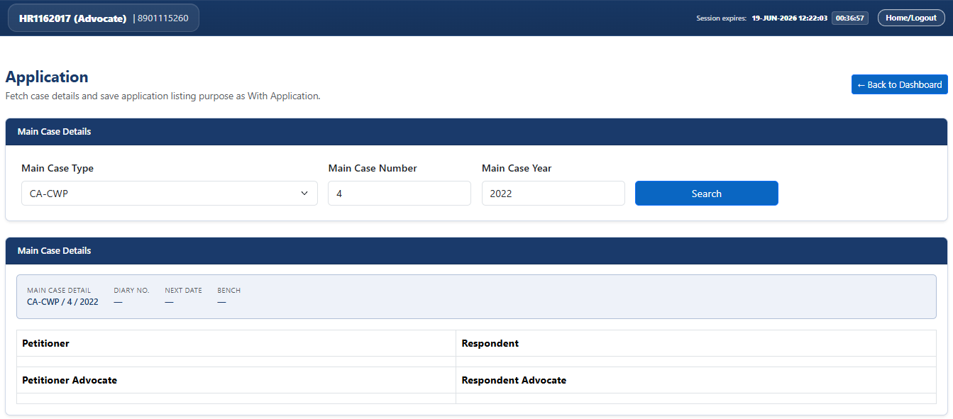
    - Legal Representation → Populates the primary names registered under Petitioner Advocate and Respondent Advocate.

Application Form Configuration
Once you verify that the fetched case records match your intent, scroll down to the With Application sub-form highlighted to define the new parameters for Step 1 of 3:

Listing Type Selection
Choose the urgency classification using the available radio options:
  - Ordinary
  - Urgent

Application Particulars Setup
  - With Application Case Type * → Select the appropriate application categorization code via the dropdown selection list (e.g., CM).
  - Listing Purpose * → Select the formal legal intent behind moving this specific application from the options listed within the dropdown (e.g., Condonation of Delay, Placed on Record, Urgent Hearing, etc.).
● + Add Application Button → If your filing requires appending multiple applications concurrently under the same primary case file, click this button to open an additional application configuration block.

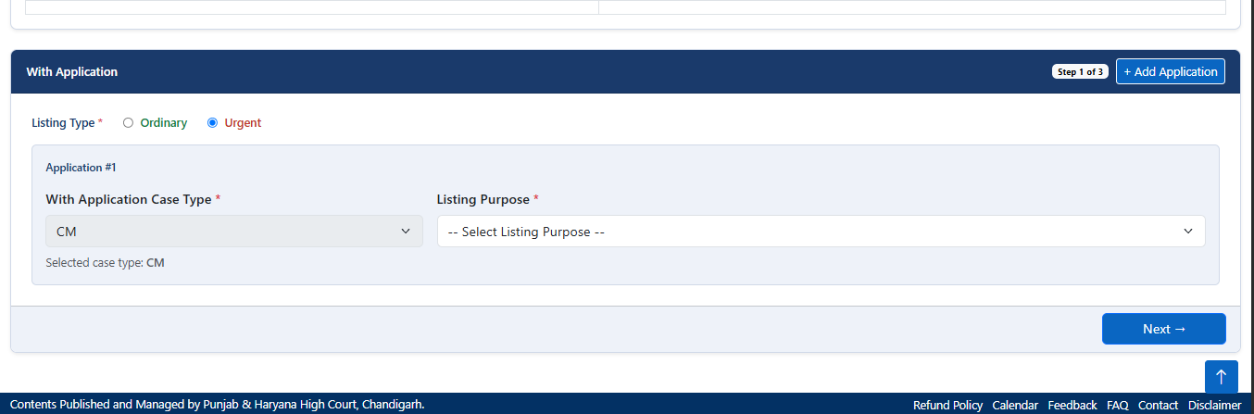

Advancing Registration
After configuring your application fields:

- Review the populated case verification panel to ensure no spelling or matching discrepancies exist.
- Verify that the chosen application purpose aligns exactly with the prayer stated in your digital PDF paperbook.
- Click the Next → button to save progress and move to the subsequent stages where you made the payment.
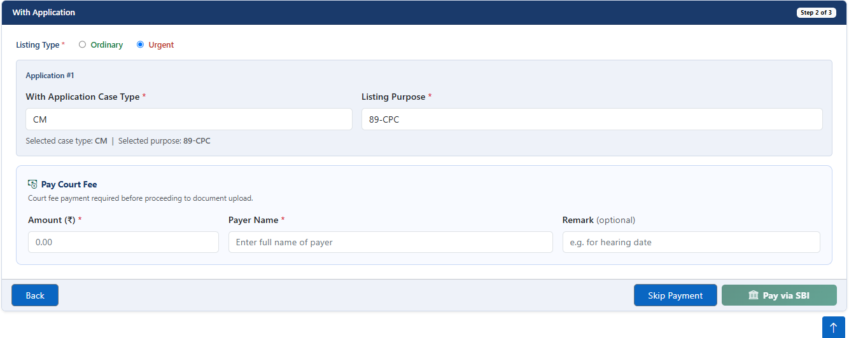

Important Notes
    - Search Mismatches → If your search query does not return results, verify that you have typed the exact registration numbers without spaces or leading zeros.

    - Field Validation → Fields flagged with a red asterisk (*) must be selected to proceed beyond Step 1.

Caveat e-Filing

Overview
The Caveat e-Filing module enables users to electronically file a Caveat before the Hon'ble Punjab and Haryana High Court. The module guides users through a structured filing process, ensuring that all required details are captured before submission.
The Caveat filing process consists of multiple steps, allowing users to enter party details, advocate information, payment details, and generate the Caveat filing reference.
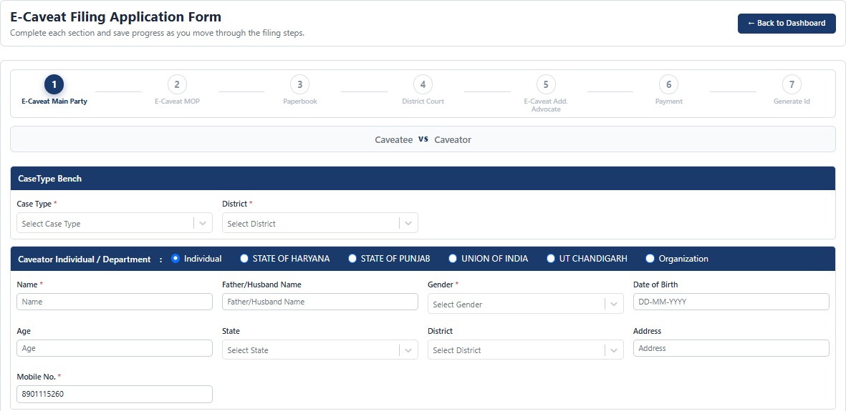

Caveat Filing Workflow
The Caveat e-Filing process is completed through the following stages:

E-Caveat Main Party → E-Caveat MOP → Paperbook → District Court → E-Caveat Additional Advocate → Payment → Generate ID.
Users can navigate through these stages sequentially by completing the required information at each step.

E-Caveat Main Party
In this step, users are required to provide the primary details of the Caveat filing.

Case Information
The following details must be selected:

    - Case Type
    - District

Party Type Selection
Users must select the appropriate party category:

Individual → State of Haryana → State of Punjab → Union of India → UT Chandigarh → Organization

Caveator Details
The Caveator section captures the details of the party filing the Caveat. Depending upon the selected party type, users may be required to provide:
Name → Father/Husband Name → Gender → Date of Birth → Age → State → District → Address → Mobile Number

Main Party Advocate Details
This section captures the advocate information associated with the Caveator. The following information is required:
Advocate Code → Enrollment Number → Enrollment Year → Advocate Name

Where applicable, advocate information may be automatically populated based on the logged-in advocate account.

Caveatee Advocate Details
Users may add advocate details representing the Caveatee. The following information may be entered:
    - Advocate Code
    - Enrollment Number
    - Enrollment Year
    - Advocate Name

This section is used whenever advocate details for the opposite party are available.
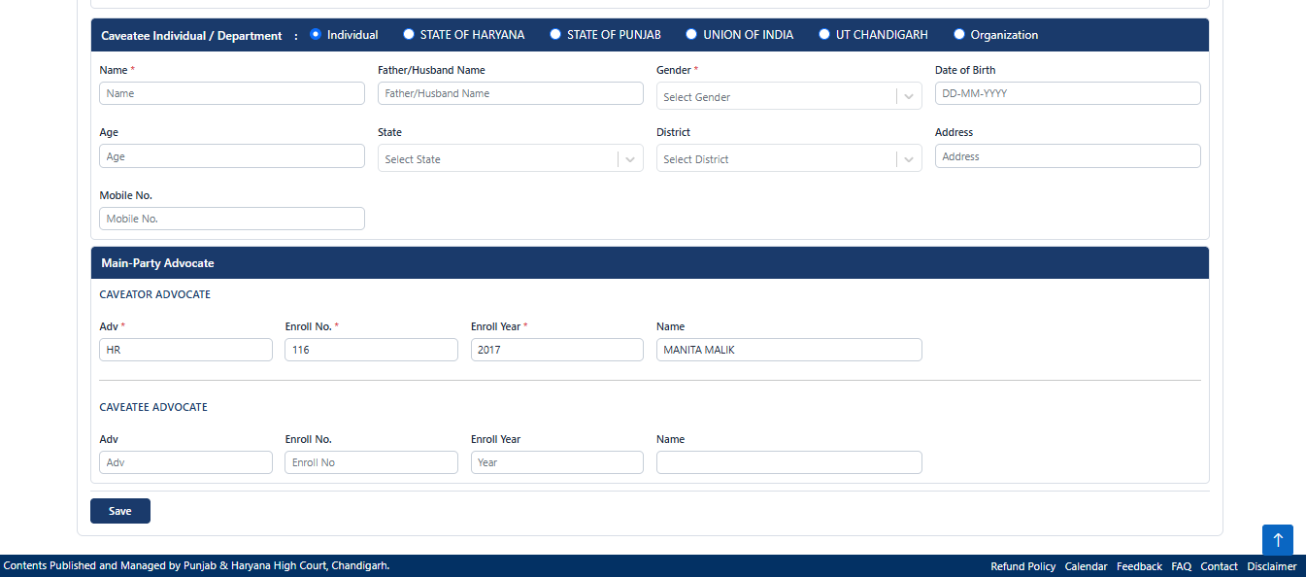

Save Information
After entering all required details:

- Review the information entered.
- Verify the accuracy of party and advocate details.
- Click the Save button.

The system saves the entered information and allows the user to proceed to the next step of the Caveat filing process.

Important Notes

    - All mandatory fields must be completed before proceeding.
    - Ensure that party details are entered accurately.
    - Verify advocate information before saving.
    - Mobile number details should be entered correctly to facilitate future communication.
    - Users should review all information carefully before moving to the next stage of filing.
    - Saved information can be reviewed during subsequent steps of the Caveat filing process.
The E-Caveat Main Party screen serves as the foundation of the Caveat filing process and captures the essential party and advocate details required for creating a Caveat filing.

Resume E-Filing and E-Caveat Drafts

Overview
The Resume E-Filing and E-Caveat Drafts module enables users to retrieve, manage, and continue working on incomplete or saved draft filings before the Hon'ble Punjab and Haryana High Court. This module centralizes all pending submissions into one combined list, ensuring that users do not need to restart a filing from scratch if a session is interrupted or if additional data validation is required.
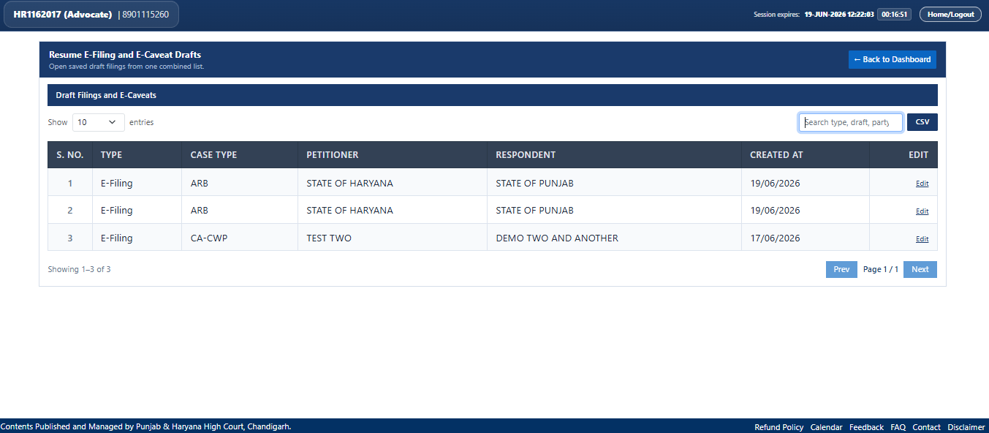

Resume Drafts Workflow

The management and resumption process is completed through the following systemic stages:

    - Filter & Locate: Find the desired draft using live global search or table parameters.
    - Verify Progress: Cross-reference case types, petitioner names, and respondent names.
    - Trigger Action: Engage the active hyperlink to reload the specific draft.
    - Resume Workflow: Continue sequentially through the remaining filing stages (e.g., Party details, Paperbook, Payment, and ID Generation).

Interface Grid & Navigation Features
The workspace provides a suite of tools designed to help advocates track down their active drafts efficiently:

    - View Entries Control: Users can change the threshold of visible entries per page using the "Show [X] entries" dropdown menu.
    - Omni-Search Engine: The "Search type, draft, party" text input box allows users to instantly search through listed entries using case numbers, party names, or filing classifications.
    - Export Records: Clicking the CSV button allows advocates to export their active registry of pending drafts into an offline spreadsheet format.
    - Pagination Navigation: Users can toggle sequentially through extensive catalogs of records utilizing the Prev and Next buttons.
    - Dashboard Return: Users can exit the draft utility screen at any point by selecting the blue ← Back to Dashboard button.

Draft Summary Registry
The primary data table captures foundational details of each saved progress file. The information is broken down into the following structural columns:

Column Name | Description
S. NO. | The serial number indicating the numerical order of the saved entries.
TYPE | Identifies the category of the application (e.g., E-Filing or E-Caveat).

CASE TYPE | The legal case classification code abbreviation (e.g., ARB, CA-CWP).
PETITIONER | The primary filing party or state entity initiating the action.
RESPONDENT | The opposing party or state entity listed in the legal matter.
CREATED AT | The historical timestamp recording when the draft was initially created.
EDIT | Action area containing the clickable hyperlink used to resume editing.

How to Resume a Draft Application
To continue a saved filing:

- Locate the specific target row within the Draft Filings and E-Caveats list.
- Navigate to the far-right column labeled EDIT.
- Click the underlined Edit hyperlink corresponding to that specific application row.
- The application will immediately redirect you to the core workflow interface, restoring all previously saved data up to the point of your last action.

Important Notes
    - Session Security Monitoring: As visible in the top header, a running countdown tracking session expiration is always active. Always resume and save modifications within the allocated session timeframe to prevent data loss or automatic logout.
    - Consolidated Database: Both standard E-Filings and E-Caveat entries are housed together; verify the "TYPE" column to ensure you are entering the correct application flow.

    - Dynamic Overwriting: Once a draft is successfully resumed, submitting any newly updated details within subsequent steps will instantly overwrite previous archival draft settings.

Reports of Submitted E-Filing

Overview
The Reports of Submitted E-Filing module (titled Combined E-Filing Reports in the system) enables users to track, monitor, and audit successfully submitted case files, applications, and
e-caveats before the Hon'ble Punjab and Haryana High Court. This module synthesizes all final submissions into a single consolidated directory, providing users with instant access to filing numbers, statuses, and legal documentation.

This interface serves as a comprehensive dashboard where advocates can review submitted cases, download receipts, check for system objections, and open uploaded documents.
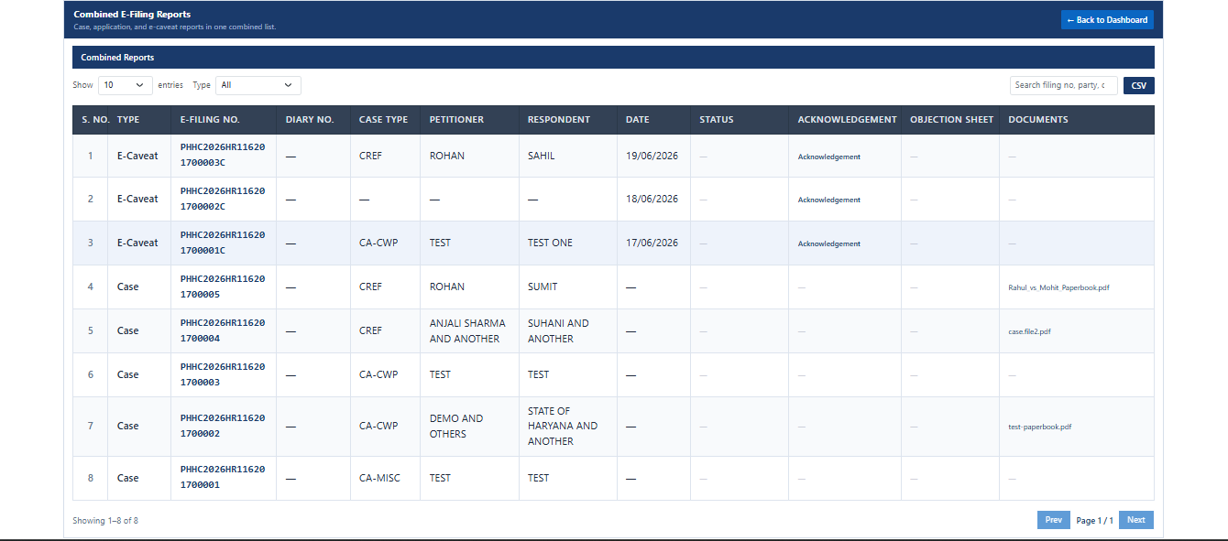

Reports Management Workflow
The data retrieval and tracking process is managed through the following systemic stages:

    - Filter Submission Category: Filter records globally or categorize submissions specifically by case or e-caveat status.

    - Track Filing Progress: Review real-time filing details, case numbers, and operational statuses.
    - Access Acknowledgements: Download verified submission receipts for administrative or tracking records.
    - Review Legal Paperbooks: Retrieve previously uploaded system files and complete case documents directly from the reporting ledger.

System Navigation & Filtering Toolkit
The reporting module includes various control features designed to simplify file auditing.

    - View Entries Control: Modify the number of rows visible per page by selecting options from the "Show [X] entries" dropdown menu.
    - Type Filter Dropdown: Refine the report data dynamically by switching the "Type"
dropdown filter (e.g., selecting All, Case, or E-Caveat).
    - Search Box Utility: Use the "Search filing no, party, c" input field to run live alphanumeric lookups across your entire submission registry.
    - Export Reports: Click the CSV button located on the top right to download a generated data log of the reports ledger.
    - Dashboard Navigation: Exit the reports portal and return to the primary work area at any time using the blue ← Back to Dashboard button.

Combined Reports Registry Structure
The centralized table monitors and classifies submission criteria under the following column layouts:

Column Name | Description
S. NO. | Tracks the numerical arrangement of submitted reports.
TYPE | Classifies the nature of the transaction (e.g., Case, E-Caveat, or Application).

E-FILING NO. | The unique systemic alphanumeric identification number assigned upon submission.
DIARY NO. | The regulatory official court diary number assigned to processing cases.
CASE TYPE | The legal grouping classification acronym (e.g., CREF, CA-CWP, CA-MISC).
PETITIONER | The individual or collective legal entity initiating the filing action.
RESPONDENT | The opposing party or state entity targeted in the petition.
DATE | The calendar date recording when the final electronic submission took place.
STATUS | Displays the current stage of review (e.g., Approved, Pending, Rejected).
ACKNOWLEDGEMENT | Contains downloadable hyperlinks to official filing submission receipts.
OBJECTION SHEET | Houses specific breakdown logs if the registry issues processing objections.
DOCUMENTS | Hosts direct hyperlinks to uploaded case paperbooks and associated PDF files.

How to Review Acknowledgements and Documents
To access receipts or files within a completed report:

- Identify the target case entry utilizing the search or page navigation parameters.
- To download your submission receipt, look under the ACKNOWLEDGEMENT column and click the Acknowledgement hyperlink.
- To view or audit your submitted paperwork, navigate to the DOCUMENTS column and select the specific file link (e.g., Rahul_vs_Mohit_Paperbook.pdf or case.file2.pdf).

Important Notes
    - Dynamic Data Synchronization: Report logs update immediately upon successful completion of any e-filing or e-caveat workflow.
    - Centralized Record Auditing: Ensure the correct "TYPE" filter is active if a specific submitted application or caveator record does not appear initially on the primary page.
    - Document Verification: Always verify that the file link appears correctly under the DOCUMENTS column to ensure the paperbook upload successfully processed to court servers.

Objection Cases

Overview
The Objection Cases module (titled Combined Objection Reports in the system) enables users to review case, application, and e-caveat objections raised by the High Court scrutiny registry. This centralized module consolidates all flagged filings into a single list, allowing users to quickly identify defects, review the specific reasons for an objection, and take corrective measures to clear them for resubmission.

When there are no active scrutiny defects against your account, the grid workspace will display a clear state letting you know that no entries require attention.

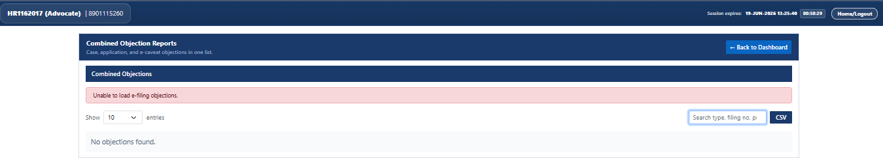

Objections Management Workflow
The checking and tracking process for scrutiny objections follows these systemic stages:

    - Access Report Panel: Open the panel to load active case and caveat flags.
    - Identify Defects: Scan flagged listings by filing number or party name.
    - Review Scrutiny Sheet: Open specific compliance reports detailing missing data or document errors.
    - Rectify and Resubmit: Correct identified issues within the primary application workflow to remove the objection.

System Filtering & Interface Controls
The interface provides standard search, sorting, and reporting tools to manage items effectively:

    - View Entries Dropdown: Controls row pagination layout limits by choosing options from the "Show [X] entries" selection menu.
    - Scrutiny Search Utility: The "Search type, filing no, pi" input box enables immediate lookup across all active reports using case specifics, filing codes, or litigant titles.
    - Export Active Logs: Advocates can click the CSV button to download a spreadsheet snapshot of their active list for offline registry coordination.
    - Exit Panel: Exit the reports system at any point by selecting the blue ← Back to Dashboard button located in the top-right corner.

Important Notes
    - Timely Compliance Tracking: Scrutiny objections should be tracked routinely. Keep an eye on the session countdown banner highlighted at the top header to ensure you stay within active working windows.
    - Corrective Workflow Integration: Once an objection is successfully answered and the draft is updated, the filing is re-queued into the scrutiny pipeline, and the corresponding entry will disappear from this panel automatically.

Update Mentioning Status

Overview
The Update Mentioning Status module enables advocates to search for submitted E-filing cases and update or review their dynamic mentioning status before the Hon'ble Punjab and Haryana High Court. This utility ensures that urgent listing requests or special benchmarking instructions are systematically appended to the active case file.

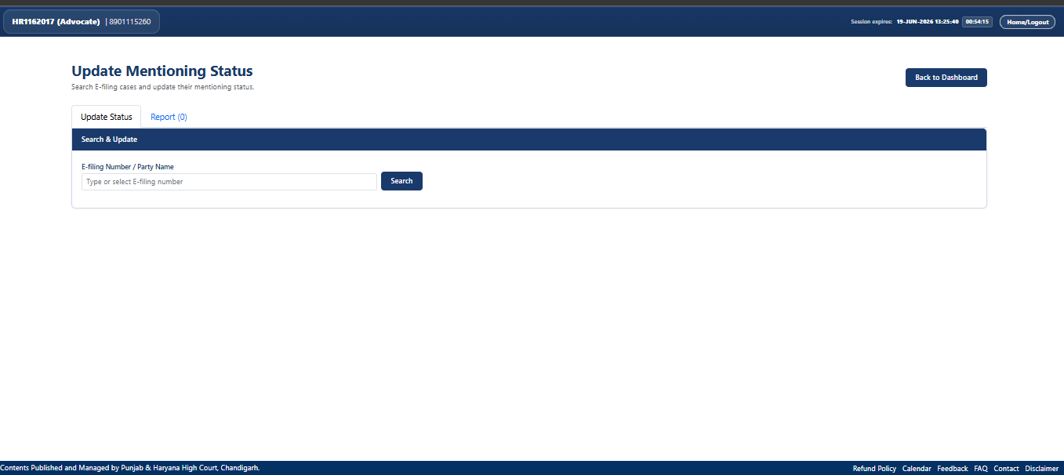
This interface features a tabbed structure containing dedicated search forms and tracking records to manage mentioning criteria effectively.

Mentioning Status Workflow

The process for updating or tracking a case's mentioning parameters consists of the following sequential actions:

    - Select Functional Tab: Toggle between the status update window or the saved report index.
    - Search Target Case: Query the system using specific transaction or party details.
    - Modify Status Details: Enter or alter the current mentioning urgency data.
    - Commit Changes: Save updates to flag the case for priority listing attention by the court registry.

Interface Navigation & Functional Tabs
The primary dashboard layout, includes several interactive navigational controls:

    - Update Status Tab: The primary workspace tab where active case searches and status modifications are initiated.
    - Report Tab: A secondary tracker labeled Report (0) that allows users to review previously generated mentioning requests or history summaries.
    - E-filing Number / Party Name Input: A dedicated entry field titled "Type or select E-filing number" used to execute direct queries against your account data.
    - Search Action Button: A dark blue button used to run lookups on entered keywords.
    - Exit Portal: Users can return to the primary portal view at any point by selecting the blue
Back to Dashboard button in the upper right quadrant.

How to Update a Case Mentioning Status
To alter or add mentioning details to an active application:

- Ensure the Update Status tab is active within the Update Mentioning Status control box.
- Click into the E-filing Number / Party Name text entry bar.
- Type or select the unique E-filing number or corresponding litigant name associated with your submitted case.
- Click the Search button.
- Once the system matches the record, update the status configuration details within the sub-form options provided on screen and save your changes.

Important Notes

    - Session Window Limits: Take note of the session tracking banner located at the far top-right header. Ensure your status queries and text modifications are submitted completely before the active countdown timer expires to prevent an automatic logout.
    - Status Accuracy: Ensure that you have selected the correct target case from the search results before saving modifications, as mentioning entries dynamically affect administrative processing order queue rules.

Additional Court Fee

Overview
The Additional Court Fee module allows users to electronically calculate and pay any supplementary court fees required for an existing e-filing case before the Hon'ble Punjab and Haryana High Court. This feature is utilized when the court registry flags a fee deficit during scrutiny, or when subsequent modifications to a case require an adjusted payment
.
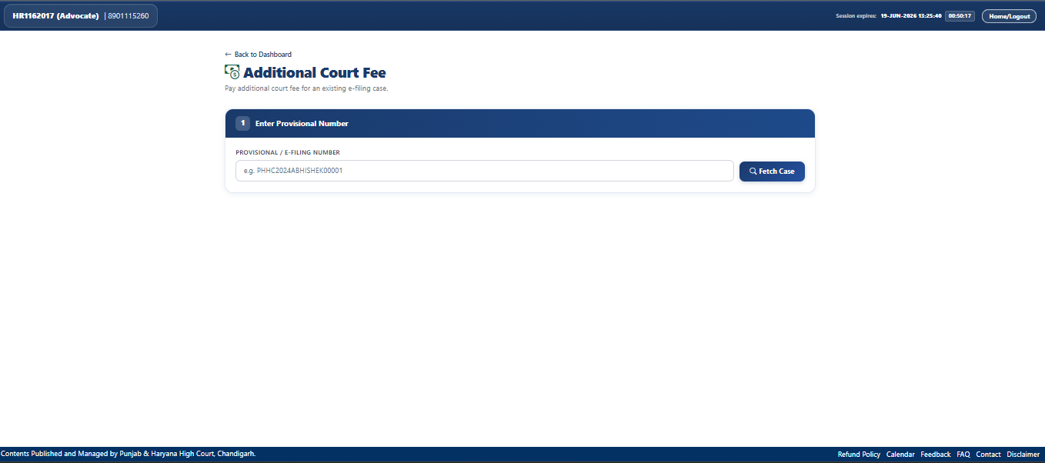
The system provides a clean, step-by-step wizard interface designed to retrieve active case records securely before processing monetary transactions.

Additional Fee Payment Workflow
The process of applying extra court fee payments consists of the following sequential stages:

    - Enter Case Reference: Query the database using a valid tracking identifier.

    - Fetch & Verify Case Data: Confirm that the retrieved case and party information match the physical file records.
    - Input Fee Details: Review the outstanding deficit amount calculated by the system or specify the fee parameters.
    - Complete Payment: Complete the digital transaction securely using the integration portal to obtain an official transaction receipt.

Interface Controls & Form Features
The initial stage of the portal workspace contains specific tracking fields and operational tools:

    - Provisional / E-Filing Number Field: A dedicated text entry box where advocates input their specific case tracking index.
    - Placeholder Example Hint: The input box contains a helpful reference format hint (e.g.,
e.g. PHHC2024ABHISHEK00001) to guide appropriate entry patterns.
    - Fetch Case Button: A dark blue action button with a magnifying glass icon used to pull related case details dynamically from the court's database.
    - Back to Dashboard Link: Located just above the step container header, allowing users to return immediately to the primary system grid.

How to Submit an Additional Court Fee
To clear an active court fee shortage or deficit:
- Ensure you have the exact primary case identification number ready.
- Locate the "PROVISIONAL / E-FILING NUMBER" text containe.
- Type your unique alphanumeric case string precisely into the input field.
- Click the Fetch Case button to load the case summary information onto the screen.
- Review the party designations, proceed to the secure integrated payment gateway options, and complete your submission.

Important Notes
    - Precise Data Entry: Ensure the case or provisional number is formatted accurately before clicking the fetch option; otherwise, the portal will reject the data call or pull up unintended record categories.
    - Session Management Alert: As visible on the upper header tracking strip, an active user session clock is running. Ensure financial transactions and database checks are performed systematically within the remaining session time to prevent mid-payment timeouts.

Secure Logout Procedure

Overview
The Logout module ensures the security and confidentiality of user accounts on the High Court E-Filing Dashboard for the Hon'ble Punjab and Haryana High Court. Properly terminating an active session prevents unauthorized access to sensitive case details, legal filings, and personal advocate profile information.
A dedicated logout function is readily accessible from the primary workspace header across all system modules.
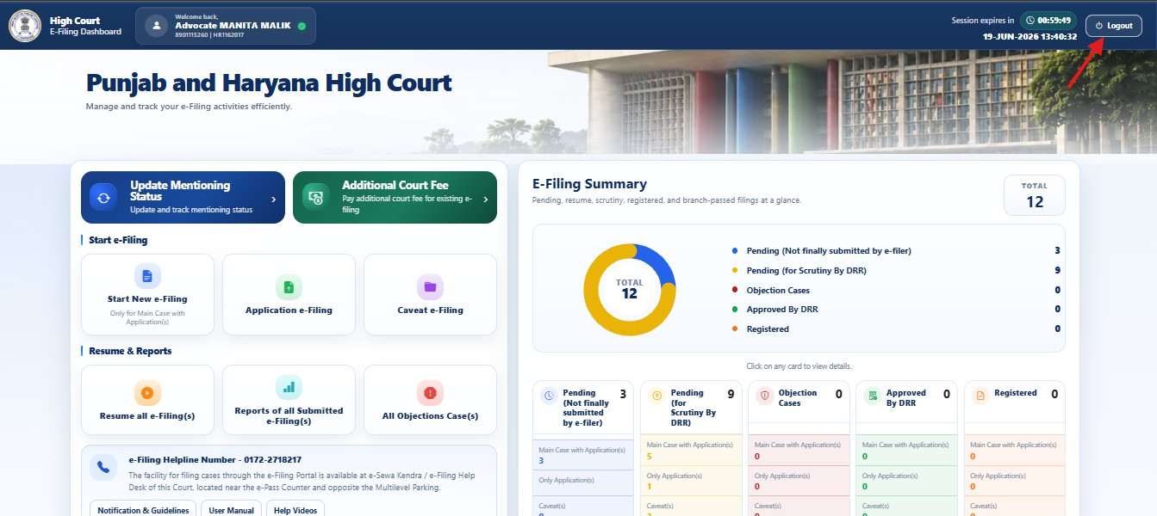

Logout Workflow
To safely terminate an active user session, the system follows these simple operational steps:

    - Locate Session Controls: Identify the system status bar at the top right of the application layout.
    - Trigger Session Termination: Click the designated logout action control to securely end user verification.
    - Clear Saved Credentials: The application instantly invalidates active authentication tokens and redirects the user safely back to the primary login splash screen.

